5.1 UI-Wireframe Specimen Collection and Tracking Screen-Shreya

1. Specimen Registration- FR17 and FR20
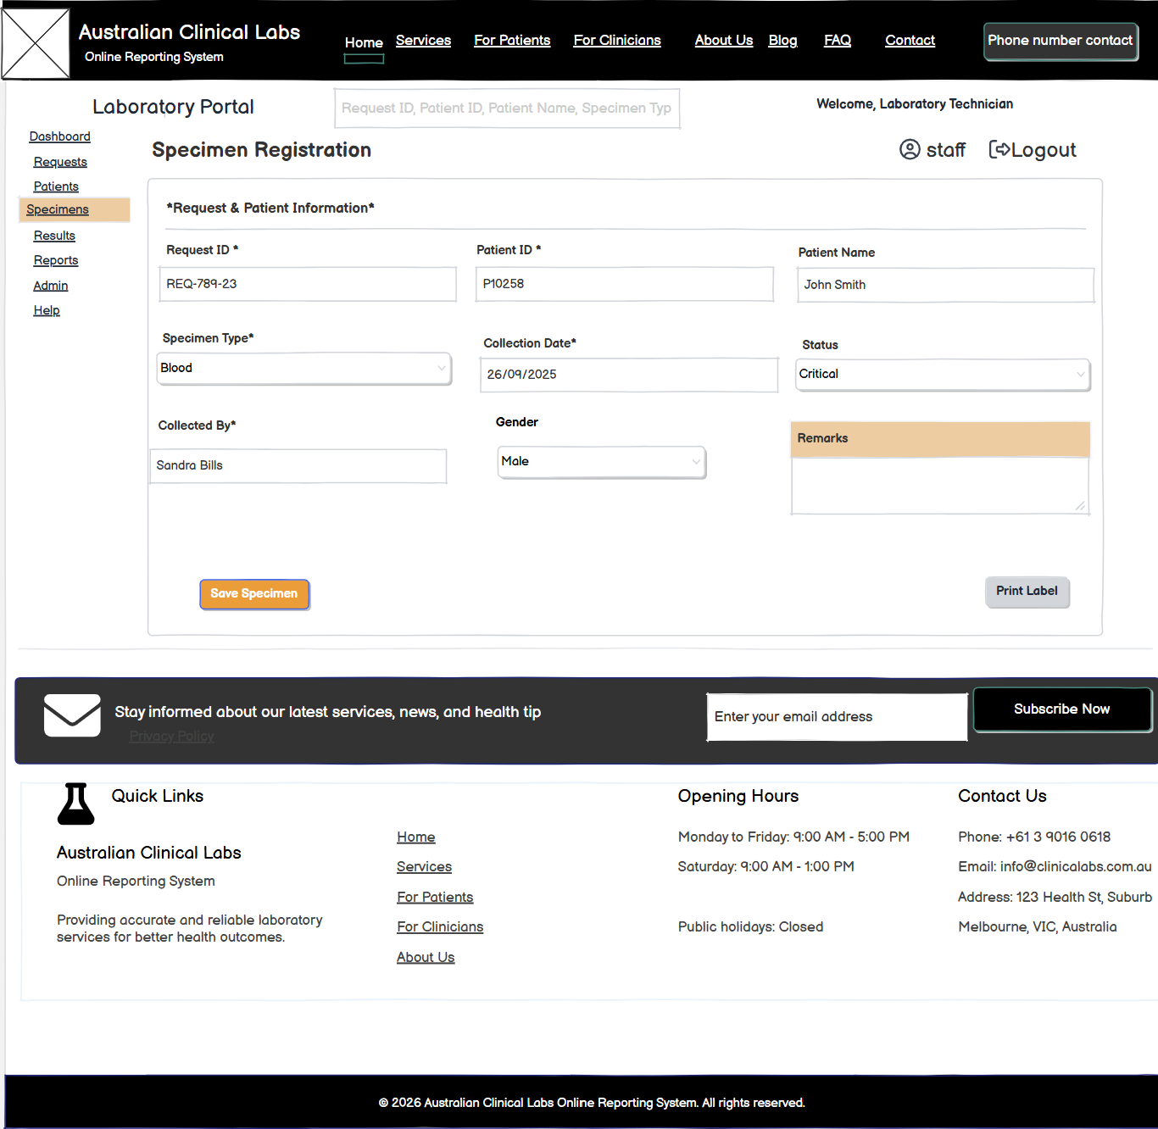Specimen Collector registers collected specimens and records collection date.

2. Barcode Generation and Label Printing- FR18 and FR19
When specimen collector registers specimens of respective patient, they can create numbers of label and print it for verification.
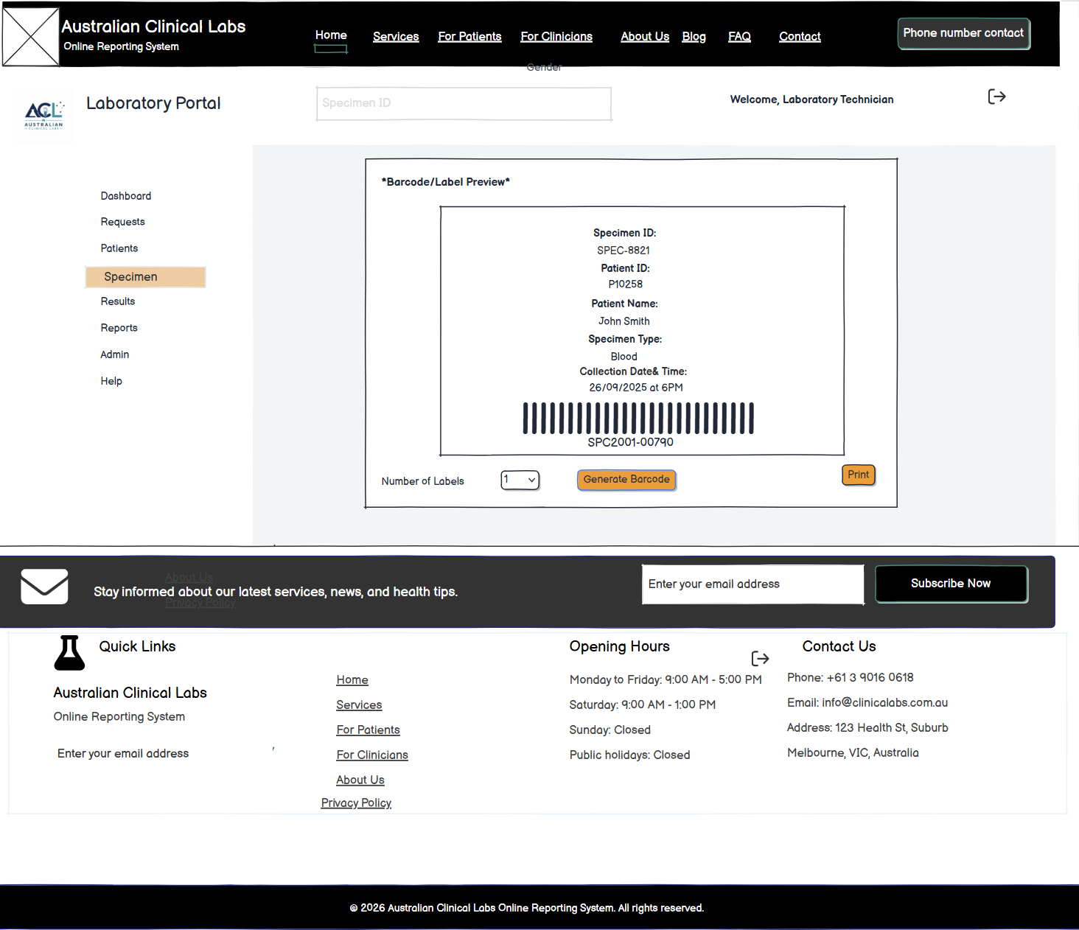

3. Specimen Collection Record- FR20
FR20 records initial specimen collection information.
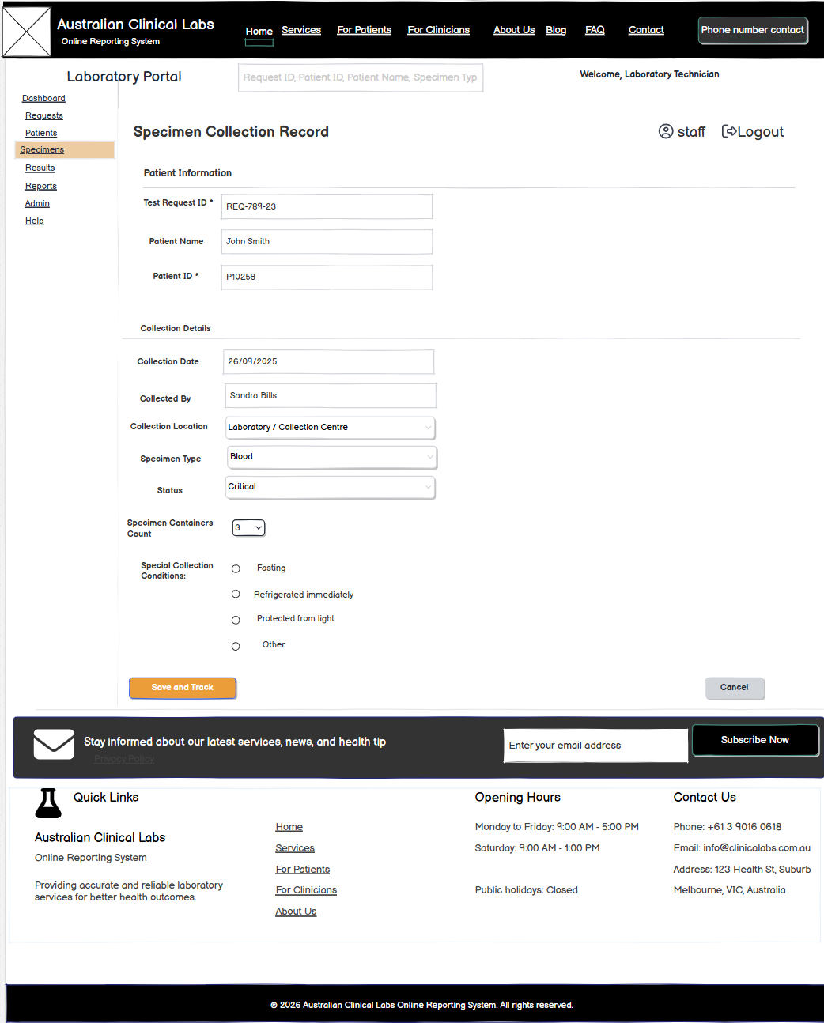

4.. Specimen Tracking- FR21
Other laboratory staff can track specimen status, and can update status.
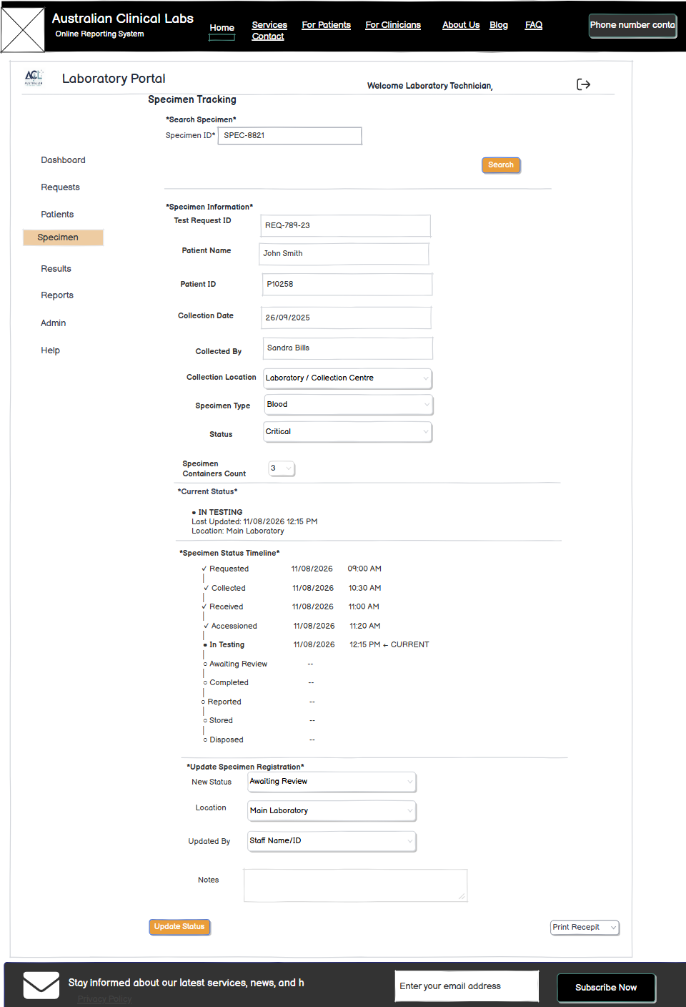

4. Specimen Receipt- FR22
If Rejected, the staff must provide additional information according to FR 23 following specimen Acceptance and Rejection Form.

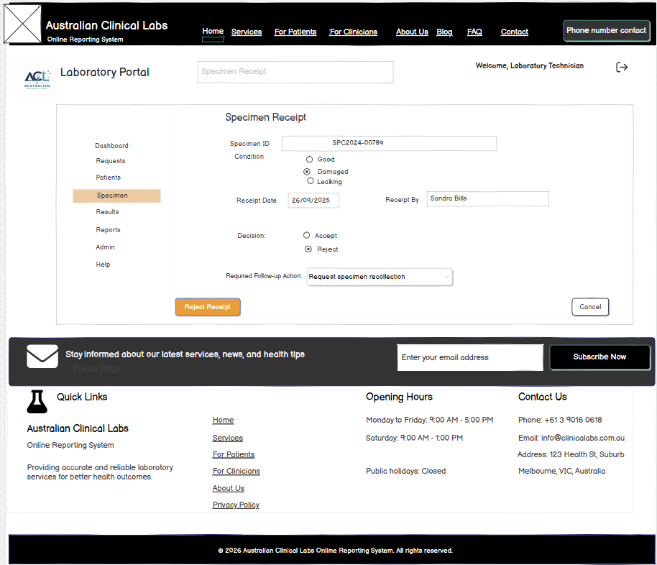
If Accepted, information should follow according to FR 23 specimen Acceptance and Rejection Form. 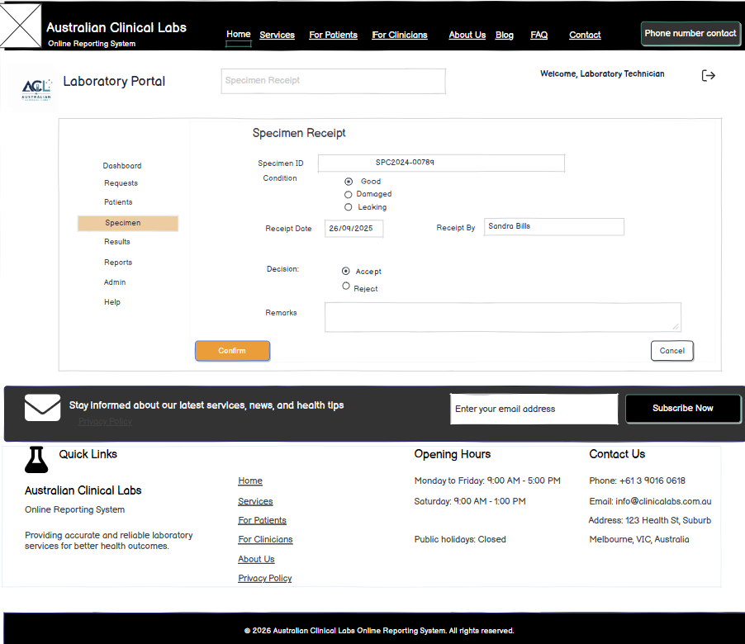

5. Specimen Acceptance and Rejection- FR23
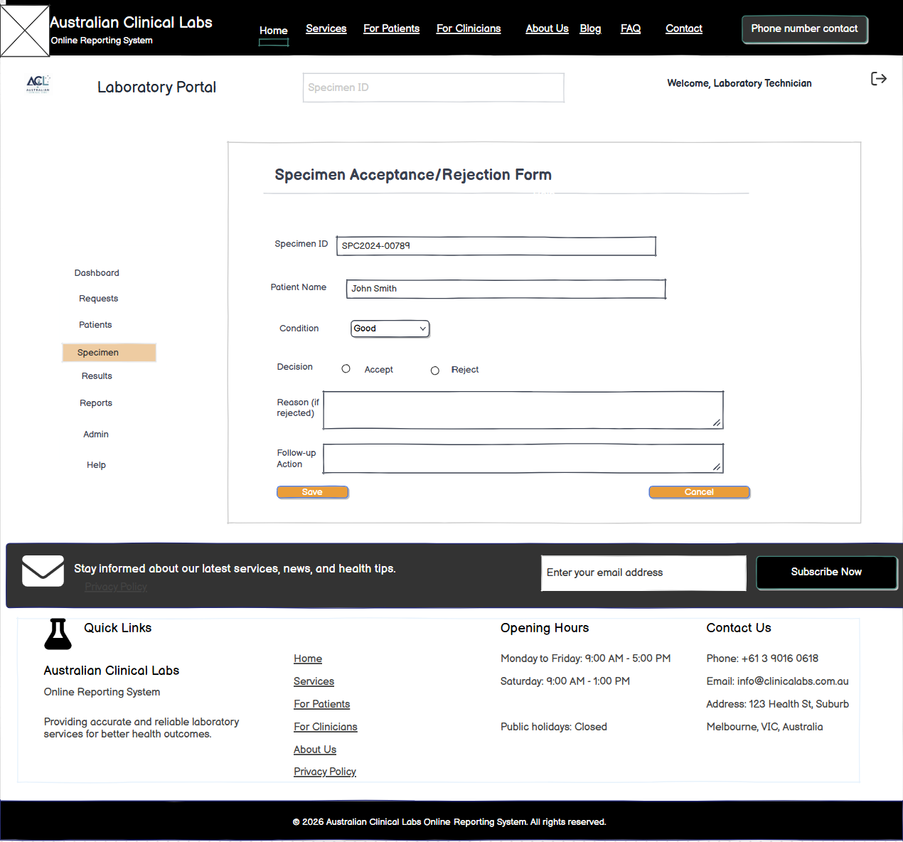

6. Specimen Recollection Request- FR24
The damaged specimens are recollected by filling up a recollection request.
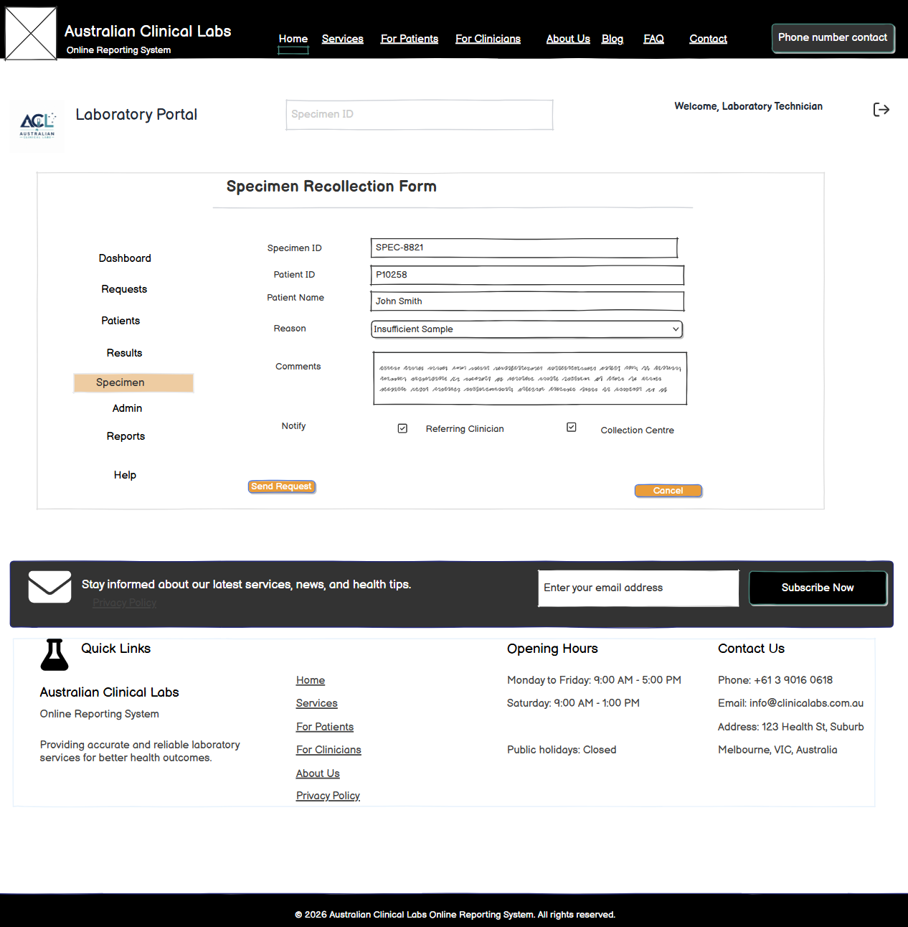

7. Specimen Recollection Information
